F3K
F U T U R E 3 0 0 0
ARCH-01 ARCHITECTURAL PANEL TEE
TECHNICAL GARMENT DEVELOPMENT
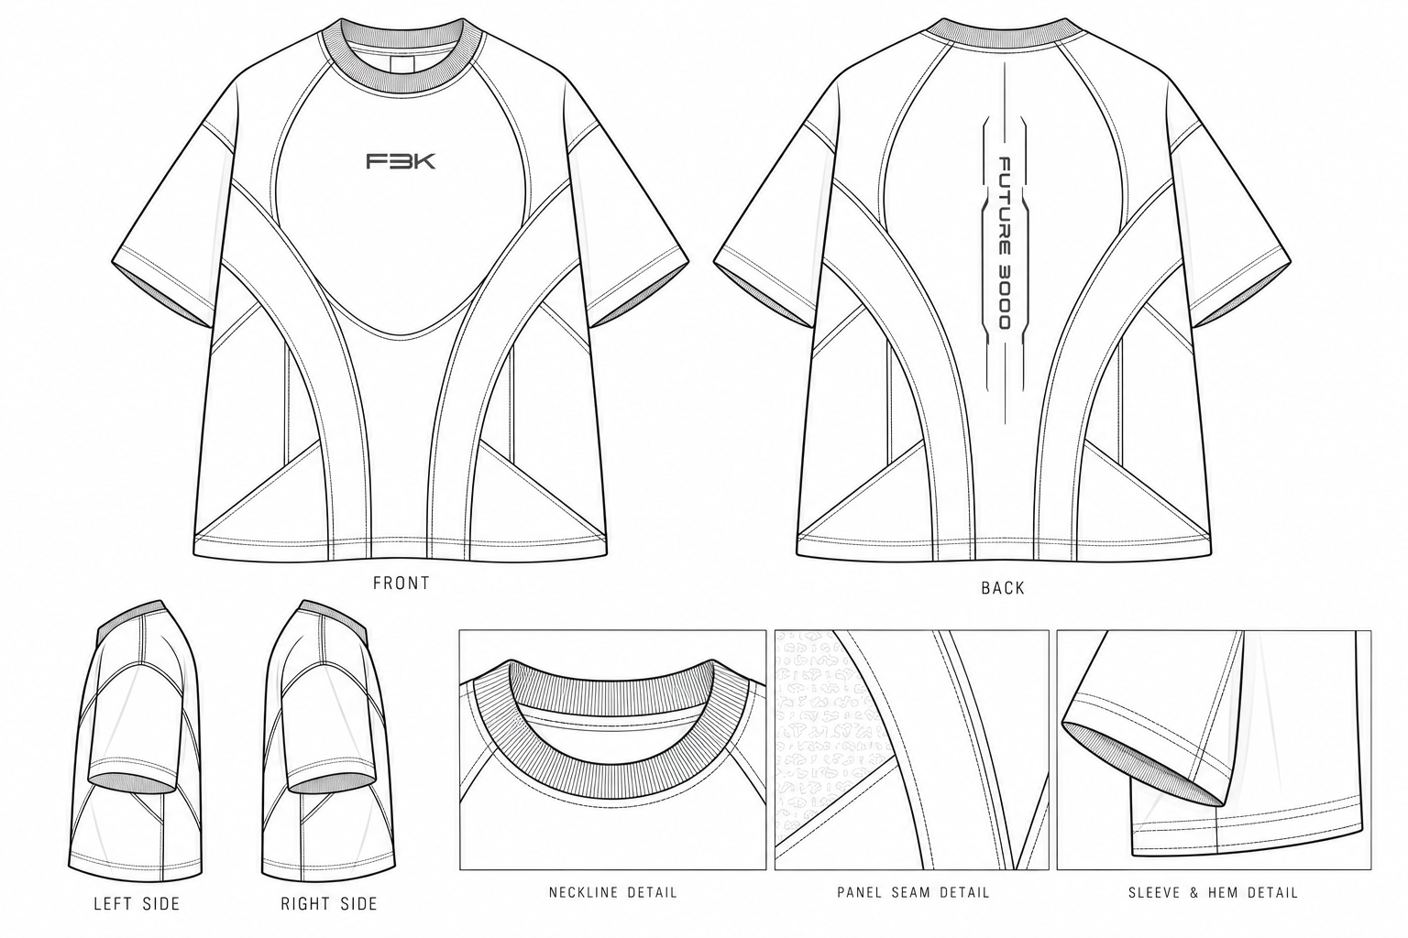
STYLE CODE F3K-TS-001 | COLLECTION 001 | REV R0
Based on supplied taupe front/back product references. Unverified specifications are provisional.

1. Design Intent & Reference Analysis
ARCH-01 is a structured oversized short-sleeve T-shirt in stonewashed taupe / warm greige. Its identity comes from curved architectural panel seams, a broad controlled silhouette, dropped shoulders, a substantial ribbed crew neckline, a centered F3K front mark, vertical FUTURE 3000 back lettering framed by linear technical details, and a subtle tonal surface texture.
Field | Specification | Status
Style code | F3K-TS-001 | Provisional
Style name | ARCH-01 Architectural Panel Tee | Proposed
Category | Short-sleeve T-shirt | Reference-derived
Fit | Structured oversized / boxy | Sample required
Size range | S, M, L, XL | Development range
Colour | Stonewashed taupe / warm greige | Reference
Construction | Curved engineered panels; visible seam definition; rib crew neck | Reference-derived
Front branding | Centered F3K mark, dark tonal contrast | Method/size pending
Back branding | Vertical FUTURE 3000 with linear framing | Method/size pending
Sample stage | S0 first prototype | Proposed

Observed vs. pending confirmation
Observed in reference | Inferred / pending
Taupe washed appearance | Exact colour standard, wash chemistry, colourfastness
Curved front/back panel lines | Exact pattern-piece count, seam paths and allowances
Ribbed crew neck and wide sleeves | Rib blend, recovery and final dimensions
F3K front mark and vertical back lettering | Artwork dimensions, method and durability
Subtle tonal texture | Knit texture vs. surface treatment
Broad boxy silhouette | Actual dimensions cannot be verified from photographs

2. Silhouette & Fit Direction
- Boxy body with controlled width and balanced body length.
- Deliberate dropped shoulders and relaxed sleeve volume.
- Substantial ribbed crew neck with recovery after washing.
- Preserve the reference panel geometry; do not add unreferenced decorative panels.
- Prioritise fabric structure, seam execution and wash appearance over graphics.

3. Fabric Specification
Parameter | Proposed specification | Status / validation
Main fabric | Premium compact cotton single jersey | Swatch required
Composition | First option 100% cotton; alternative cotton/elastane blend | Supplier confirmation
Knit construction | Dense compact single jersey | Proposed
Target GSM | 260 GSM starting target | Verify actual GSM
Hand feel | Dense, soft, substantial; controlled drape | Physical assessment
Colour | Stonewashed taupe / warm greige | Approve swatch
Surface texture | Subtle tonal all-over texture | Method pending
Finish | Piece wash or garment wash after trials | Wash trial required
Shrinkage | Target maximum 3% lengthwise and widthwise | Target only; test pending
Stability | Check neckline recovery, panel stability, hem distortion | Sample validation
Colourfastness | Wash and rubbing tests | Pending
Supplier/reference | Not assigned | To source

Start with a 260 GSM compact cotton jersey. Test whether it retains the raised curved seams and body shape after washing. The tonal texture may come from the knit or a surface treatment; do not assume it can be reproduced by printing alone.

4. Finished-Garment Measurement Chart — S to XL
All dimensions are in centimetres and refer to the finished garment laid flat unless stated otherwise. These are proposed starting measurements, not verified dimensions from the photographs. M is the provisional base size. Tolerances are proposed ± limits requiring factory agreement.
No. | Point of measurement | How to measure | S | M | L | XL | Tol. ±
1 | Half chest width | Flat, 2.5 cm below armhole | 58 | 61 | 64 | 67 | 1.0
2 | Body length (HPS) | HPS at neck seam to bottom edge | 68 | 70 | 72 | 74 | 1.0
3 | Shoulder width | Outer shoulder point to outer shoulder point | 56 | 59 | 62 | 65 | 1.0
4 | Sleeve length | Shoulder point to sleeve hem | 22 | 23 | 24 | 25 | 0.7
5 | Sleeve opening | Flat straight across sleeve hem | 21 | 22 | 23 | 24 | 0.5
6 | Armhole depth | Vertical HPS level to underarm level | 25.5 | 27 | 28.5 | 30 | 0.7
7 | Neck opening width | Straight across neckline at seam line | 18 | 19 | 20 | 21 | 0.5
8 | Front neck drop | HPS level to lowest front neck point | 8 | 8.5 | 9 | 9.5 | 0.5
9 | Back neck drop | HPS level to lowest back neck point | 2.5 | 2.5 | 2.5 | 2.5 | 0.3
10 | Neck rib height | Attachment seam to outer rib edge | 2.5 | 2.5 | 2.5 | 2.5 | 0.3
11 | Bottom hem width | Flat straight across bottom edge | 58 | 61 | 64 | 67 | 1.0
12 | Bottom hem depth | Visible finished hem band | 3 | 3 | 3 | 3 | 0.3
13 | Bicep width | Flat across sleeve near armhole | 23 | 24 | 25 | 26 | 0.7
14 | Shoulder drop | Vertical HPS to shoulder/sleeve junction | 10 | 11 | 12 | 13 | 0.7

Additional panel and branding layout targets
Feature | S | M | L | XL | Tol. ± | Notes
Central front panel width at chest | 30 | 32 | 34 | 36 | 0.7 | Pattern-derived
Central back panel width at chest | 30 | 32 | 34 | 36 | 0.7 | Pattern-derived
Side panel width at chest, each side | 8 | 8.5 | 9 | 9.5 | 0.5 | Pattern-derived
Sleeve hem depth | 3 | 3 | 3 | 3 | 0.3 | Finished depth
Front F3K logo width | 6 | 6 | 6.5 | 6.5 | 0.3 | Artwork width
Back lettering max. width | 2.5 | 2.5 | 2.5 | 2.5 | 0.3 | Artwork width

Panel widths must be reconciled with actual seam paths and allowances; they cannot simply be added to reproduce body width. Pattern maker to establish consistent measurement points before grading. HPS = high point shoulder.

5. Construction Details
No. | Part / location | Construction method | Stitch type | Allowance | Notes
1 | Shoulder seams | Join front/back shoulder seams | 4-thread overlock | 10 mm | Confirm balance
2 | Neckband | Attach rib evenly | Overlock; optional topstitch | 6–7 mm | Test recovery
3 | Sleeve attachment | Set sleeve into armhole | 4-thread overlock | 10 mm | Match notches
4 | Front curved panels | Join engineered edges | Overlock + optional topstitch | 10 mm | Preserve curves
5 | Back curved panels | Join engineered edges | Overlock + optional topstitch | 10 mm | Center branding
6 | Side seams | Join front/back body | 4-thread overlock | 10 mm | Balanced profile
7 | Sleeve panel seams | Join relevant sleeve sections | Overlock + optional topstitch | 10 mm | Symmetry
8 | Bottom hem | Turn up and secure | 2-needle coverstitch | 30 mm turn-up | Check visible depth
9 | Sleeve hems | Turn up and secure | 2-needle coverstitch | 30 mm turn-up | Symmetry
10 | Front logo | Apply F3K artwork | Embroidery/transfer TBD | N/A | Wash test
11 | Back branding | Vertical FUTURE 3000 | Method TBD | N/A | Confirm spacing
12 | Stress points | Reinforce only if needed | Backtack/bar tack | As required | Avoid unnecessary detail

Allowances are proposed starting points. Confirm against fabric behaviour, seam design and factory machinery. Establish whether raised seam definition comes from topstitching, piping or another finish during S0.

6. Colourways
Colourway | Fabric direction | Branding / stitch | Status
01 — Stone / Taupe | Warm stonewashed greige | Dark charcoal | Primary reference
02 — Obsidian | Washed charcoal black | Tonal silver-grey | Proposed alternative
03 — Graphite | Deep graphite grey | Pale grey or tonal | Optional future colourway

No Pantone standard is approved. Confirm physical swatches or lab dips under controlled lighting before locking production colour.

7. Bill of Materials (BOM)
No. | Component | Specification | Colour | Qty / garment | Supplier / status
1 | Main fabric | Compact cotton jersey, 260 GSM target | Stone taupe | Approx. 0.85–1.10 m* | To source
2 | Neck rib | Recovery-tested rib knit | Matching taupe | Approx. 0.08 m* | To source
3 | Sewing thread | Polyester suitable for knit construction | Matching | Factory usage | Confirm
4 | Front logo | F3K artwork application | Dark charcoal | 1 application | Method pending
5 | Back branding | Vertical FUTURE 3000 artwork | Dark charcoal | 1 application | Method pending
6 | Main label | Woven/printed, 60 × 20 mm proposed | Black/grey | 1 pc | Artwork pending
7 | Size label | S/M/L/XL identifier | Black/grey | 1 pc | Pending
8 | Care label | Fibre, care and legal details | Neutral | 1 pc | Pending
9 | Reinforcement | Only if required by sample | Matching | As needed | Factory decision
10 | Hangtag | Minimal matte card | Black/grey | 1 set | Optional

*Fabric consumption is an estimate, not a cutting-marker calculation. Final usage depends on graded patterns, usable width, marker efficiency and cutting allowance. Supplier and laboratory data are not confirmed.

8. Labels & Packaging
Component | Proposed dimensions | Placement | Specification / status
Main label | 60 × 20 mm | Inside back neck | Minimal F3K identity; artwork pending
Size label | Approx. 15 × 20 mm | Adjacent to main label | Separate size identifier
Care label | Approx. 25 × 60 mm | Inside side seam | Fibre/care/legal details pending
Hangtag | Approx. 50 × 90 mm | Near neck | Matte card; optional
Garment packaging | Sized to folded garment | Outer packaging | Minimal protective packaging; confirm need

9. Branding & Placement
- Front: centered F3K mark on central chest, following reference; proposed width 6–6.5 cm by size.
- Back: vertical FUTURE 3000 lettering centered on back panel with linear technical framing; proposed maximum width 2.5 cm.
- Use dark charcoal branding on taupe, subject to contrast and wash testing.
- Confirm embroidery, transfer or another application method; reference does not establish the technique.
- Keep panel seams from distorting logos or interfering with back lettering.

10. Technical Review & Validation
Check | Required validation | Approval gate
Panel geometry | Match curves, intersections and symmetry; confirm actual panel count | Before S0 approval
Fit and grading | Check chest, length, shoulder drop, armhole, sleeve and neck; grade all sizes | Before S1
Fabric and texture | Confirm GSM, composition, hand feel, texture and wash behaviour | Before S1
Shrinkage | Measure before/after agreed wash method | Before pre-production
Seam finish | Inspect curved seams for puckering, bulk and stitch appearance | S0 / S1
Branding durability | Check placement, wash and abrasion performance | Before pre-production
Colour | Approve physical swatch/lab dip under controlled lighting | Before bulk
BOM/consumption | Confirm marker-based fabric use and supplier details | Before costing/bulk
Labels/compliance | Approve artwork and required care/fibre details | Before bulk

11. Recommended Sampling Sequence
Stage | Purpose | Required output
S0 — First prototype | Validate silhouette, panels, fabric weight and neckline | Physical sample + measurement review
S1 — Revised prototype | Correct fit, seam alignment, branding and finish | Revised sample + updated measurements
S2 — Pre-production | Verify materials, grading, labels and construction | Approved PP sample + signed-off spec
Bulk approval | Release only after critical checks pass | Approved materials, pattern, BOM and production spec

12. Assumptions & Open Items
- No verified physical garment measurements or sample were supplied; dimensions are proposed and require fit validation.
- Exact composition, supplier, surface texture method, colour standard and shrinkage results are unknown.
- Exact panel count, pattern geometry, allowances and construction order require pattern-maker confirmation.
- Final logo artwork, application method, Pantone references and branding dimensions are not approved.
- Chart values are finished-garment dimensions, not body measurements.
- The technical flat is a development drawing, not a validated sewing pattern or graded pattern set.
- Do not release bulk production until fit, wash behaviour, materials and branding have been approved.
F3K — FUTURE 3000 | ARCH-01 TAUPE PANEL TEE | END OF DOCUMENT

